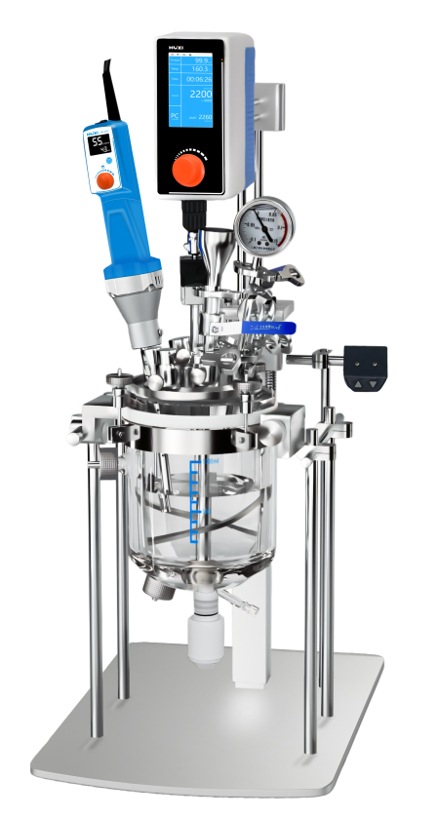

HR-1LAS Laboratory vacuum emulsification reactor

Application：
● Laboratory vacuum emulsification reactor: Under the environment of vacuum or pressure, to achieve the material dispersion, emulsification, homogenization, mixing and other processes.It can be equipped with a variety of high viscosity agitators, high shear homogenizer or emulsifiers and reliable vacuum sealing systems and temperature control systems. A variety of sensing and testing systems can simulate industrial production in the laboratory.
● Main Applications:
- Production of cream, lotion and emulsions
- Pharmaceuticals and cosmetics
- Disperse fine solids into liquids or dissolve them
- Suspend additives and solid polymer in mineral oil
- Wet grinding in fluids and polymers, dispersing solids, fibers, high-viscosity substances, cell tissues, etc.
- Handling daily necessities and food
- Polymerization
- Extracting Enzymes in the Body
- Others

Main Features：
- The homogeniser and Mixer are adopt with brushless motors to provide a brushless working scenario and prevent carbon powder from contaminating the samples;
- User-friendly design:
- One-key electric lift reactor lid; electric lift with anti-pinch function;
- The reactor lid is supported by two springs and has a cushion function to prevent it from being damaged;
- The kettle body can be turned over, conveniently for dumping materials;
- The kettle body is equipped with a turnover hot and cold water pipe interface, which is convenient for dumping samples;
- The kettle cover has a screw fixing slot, which is convenient for fixing;
- The cover screws are equipped with anti-collision devices to prevent the kettle from being knocked;
- Homogenizer working head with safety protection buckle to prevent bumping the kettle;
- Different types of mixers can be selected according to the viscosity and volume of the sample.
- SS304 base plate and support rod,easy for cleaning;
- Can be connected to HUXI online emulsification for multi-machine emulsification, to improve efficiency and effect;
- The stirring bar is connected with the kettle body by anchor claw, which greatly improves the stirring jitter and noise;
- Anchor type PTFE wall scraping stirring paddle to prevent the sample from sticking to the wall and clumping;
- External cooling water circulation refrigeration can be connected to control the sample temperature.

Techncial Parameters：
Model | HR-1LAS
Item No. | 1018022001
Power Supply | 220V 50/60HZ
Stirring Volume(ml) | 300-1000
Emulsification Volume(ml) | 300-1000
Operating Temperature(℃) | -20~120℃
Accessible Vacuum(mpa) | -0.096mpa
Viscosity(cp) | 70000cp
Stirring Speed Range(rpm) | 0-360rpm
Stirring Paddle Configuration | Stainless Steel Anchor Screw with Wall Scraping Agitator Paddle
Scraper material | Standard PTFE, optional silicone rubber
Homogenizer Motor Type | Brushless motor, Continuous work
Homogenizer Motor Power(w) | 1050W
Homogenizer Speed Display | Digital
Homogenizer Speed Range(rpm) | 4000-26000rpm
Homonigezer Working Head Configuration | 25DG
Reaction Kettle Lid Material | SS316
Reactor Kettle Lid Opening | Homogenizer port + hopper port + temperature measuring port + vacuum port +3 spare ports
Reactor Lid Lifting Mode and Stroke | Electric lift, stroke 660mm
Sample Touch Material | SS316L, borosilicate glass, FKM10, PTFE
Vacuum Port Outer Diameter(mm) | 10mm
Glass Kettle Jacket Inlet and Outlet Outer Diameter (mm) | 12mm
Ambient Temperature(°C) | 5-40
Relative Humidity(%) | 80
External Dimension(mm) | 480*400*840（长*宽*高）
Standard weight(kg) | 48
Packing List：
Configuration | Item | Quantity
Standard | Kettle host (electric lifting bracket, 1L high borosilicate glass kettle body, SS316 kettle cover) | 1set
Standard | HR-25D Homogenizer | 1pcs
Standard | RWD50 Overhead Stirrer | 1pcs
Standard | Working head（25DG） | 1pcs
Standard | Power Line | 1pcs
Standard | Instruction manual & certificate & warranty card | 1pcs
Optional | AS Series Stirrer | 1pcs
Optional | AS Series Homogenizer | 1pc
Optional | Pirani vacuum gauge | 1set
Optional | Thermostatic Bath | 1pcs
Optional | Vacuum Pump | 1pcs

