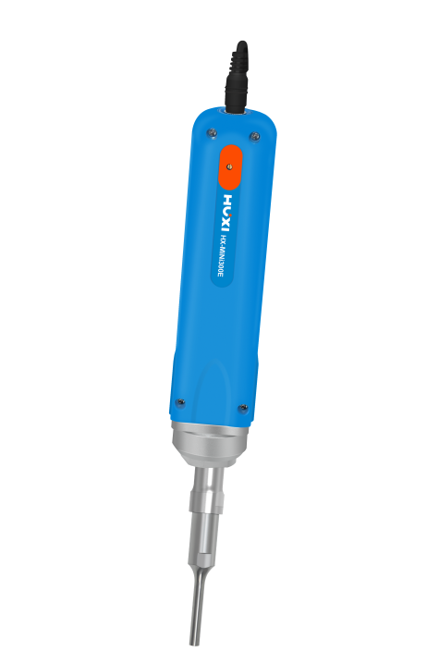

HX-MINI300E Mini Ultrasonic Homogenizer

Application：
● MiNi ultrasonic breaker HX-MiNi300 is a sample pretreatment instrument with integrated structure design and the use of ultrasonic waves to produce cavitation effect in liquid, which is mainly suitable for the dispersion of nanomaterials, cell wall breaking extraction and crushing, homogenization and mixing, chemical synthesis, oil-water emulsification, etc.

Main Features：
● It is suitable for dispersion of nanomaterials, cell wall-breaking extraction and pulverization, homogenization and mixing, chemical synthesis, oil-water emulsification, etc.
● A variety of horn specifications are available, with a wide processing range, up to 300ml. The hornis made of titanium alloy material, which has high strength, strong corrosion resistance, high heat resistance and long service life
● Frequency tracking and amplitude compensation adopt automatic mode, with stable load and high electro-acoustic conversion rate
● It can be hand-held or can be fixed with an optional bracket. It can be used in a variety of ways, especially for the ultrasonic treatment of trace or small amount of samples.

Techncial Parameters：
Model | HX-MINI300E
Item No | 1008047003
Power | 10-300W(Manual analogue adjustable)
Capacity | 0.1～300ml
Ultrasonic control method | manual key
Single ultrasonic time | ＜40min
Operation mode | continuous
Frequency | 30KHz
Standard Horn | Φ6mm
Optional Horn | Φ2、6、8
Horn Material | TC4 Titanium alloy
Input Voltage | 100-230V/AC or 12-24V/DC
Optional Features | Fixed bracket
Voice alarm and alert function | Protection occurs, power cord flashes
Shell Material | ABS
Instrument Size(L*W*H） | 300*φ43
Package Size(L*W*H） | 338*288*110
NW | 0.5
GW | 1

Accessories：
Item No. | Horn | Capacity ml | Nominal power
20080073 | Φ2 | 0.1~5 | 150
20080072 | Φ6 | 5~100 | 250
20080074 | Φ8 | 30~300 | 300

Packing List：
Name | Quantity
Host | 1pcs
Power | 1pcs
User Manual | 1pcs
Certificate of Conformity & Warranty Card | 1pcs
Horn（6mm） | 1pcs
No. 14 open-end spanner | 1pcs
No. 19 open-end spanner | 1pcs

