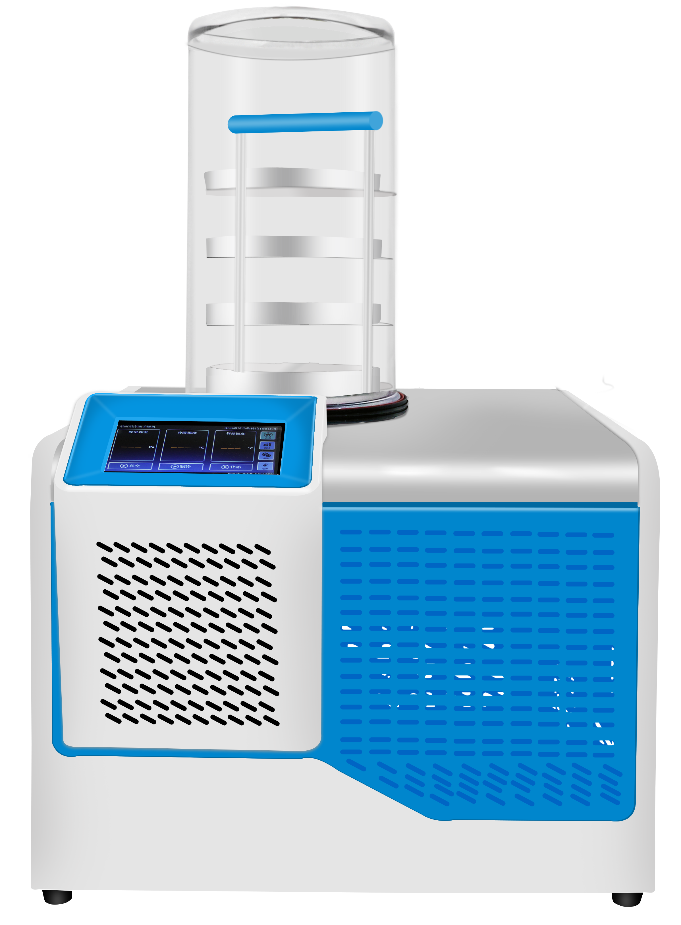

HXLG-10-50B Standard Table top freeze dryer

Application：
● The main principle of freeze dryer is a low-temperature drying equipment that uses sublimation to dehydrate materials, freezes water-containing materials into solids, and uses the sublimation properties of water under low temperature and low pressure conditions to dehydrate materials at low temperature and achieve a new drying method. It is suitable for biological Research, medicine, pharmacy, chemical industry, food processing, colleges and universities and other fields for freeze-drying, strain preservation and other fields. The desktop freeze dryer series is divided into four types: ordinary type, top press type, multi-manifold type, and top press multi-manifold type.

Main Features：
● Rapid cooling, uniform temperature on the inner wall of the cold trap, professional gas diversion technology, good water replenishment effect;
● Brand compressor, single-machine mixed environmental protection refrigeration technology;
● Equipped with cold trap sample pre-freezing function, no need for ultra-low temperature refrigerator or liquid nitrogen treatment;
● 7-inch color LCD touch screen, friendly human-computer interaction interface, equipped with lock screen function, and optional mobile phone and computer remote control;
● The display screen shows parameters such as cold trap temperature, vacuum degree, sample temperature, running time, etc., and also sets the management authority for misoperation;
● With data viewing, exporting and deleting functions, freeze-dried data is automatically saved, which can effectively prevent data loss, and also supports USB data export;
● Supports lyophilization of ampoules, vials, glass flasks, plasma vials or trays;
● The cold trap has the independent pre-freezing function of the sample in the early stage, and is equipped with a one-key defrosting function;
● Built-in maintenance reminder function to remind users to maintain the instrument;
● With vacuum alarm function, it can timely remind users whether the vacuum degree is normal;
● Equipped with high-precision micro-adjustment vacuum valve, which can realize micro-adjustment of vacuum degree;
● The vacuum connecting pipe is made of stainless steel anti-corrosion material, with standard KF25 vacuum clamp.

Techncial Parameters：
Model | HXLG-10-50B
Type | Standard
Freezing area | 0.12㎡
The number of Schering bottles | φ12mm 920
The number of Schering bottles | φ16mm 480
The number of Schering bottles | φ22mm 260
Cold trap size | φ220*220mm
Cold trap temperature | -60℃
Ability to Capture Water | 4(kg/batch)
Vacuum Degree | ≦5Pa（no load）
Extream vacuum degree | 2PA
Sample tray size | 200mm totally 4 layers
Motor Power | 1040W
Motor weight | 57kg(Cover accessories are not included)
Exterior Dimension(mm) | 625*558*480
Power Supply | AC220V 25A 50HZ
Applicable environment | ambient temperature≦25℃
Machine running noise | ≦55dB

