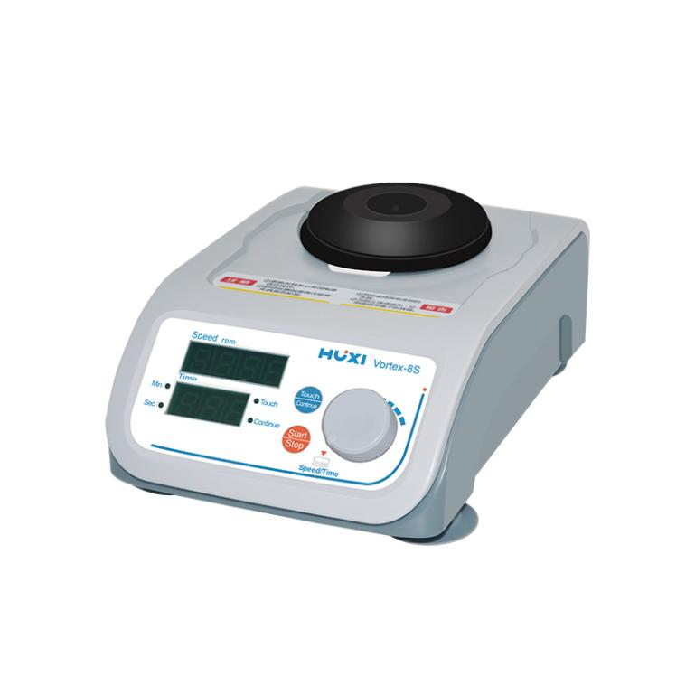

Vortex-8S Multi-Tube Vortex Mixer

Application：
●Vortex-8S multi-purpose vortex mixer adopts advanced design concept and manufacturing technology with simple,smooth and beautiful appearance and compact and solid structure, which makes this model with the advantages of high versatility and easy operation, ensuring it can quickly handle micro plate type and small test tube type of oscillatory mixing experiments.
Main Features：
● ST intelligent analysis and processing platform can respond to various modes of working requirements sensitively, fully equipped with fast processing chipset and electronic sensing technology, easily realizing intelligent control of speed, time and working mode;
● Richer fixture accessories to meet the needs of different volumes of test tubes and plates, and efficient expansion to ensure their experiments are carried out quickly;
● Perfect structural optimization design of the body, so that it has enough counterweight weight and eccentric balance operation, providing a stable and quiet working platform for various oscillatory mixing;
● Efficient permanent magnet rotor makes the motor not easy to heat up, with over-temperature protection characteristics, to ensure that high-speed mixing can still be a long time trouble-free work, no carbon brush design, simple integration, no extra accessories, reduce running resistance, more powerful, reduce noise, to avoid interference;
● Two safe operation modes "point" and "continuous", easy and simple to switch, can quickly identify the highest speed of various fixtures to ensure its safe use,time function with positive timing and countdown time to make the experiment more convenient and accurate.

Techncial Parameters：
Model | Vortex-8S
Motor/drive mode | DC24V permanent magnet brushless motor/direct drive
Control mode | PWM stepless adjustment
Operation mode | point-and-push/continuous mode
Power Fuse | PPTC/self-restoring fuse/no need to replace
Max load | 1.5Kg
Speed range | 200-3000r/min.±15rpm
Shaking mode | Orbital Shaking
Orbital diameter | 4.5mm
Fixture identification function | Automatic identification/safety and efficiency
Speed function/display | Full number of segments/high bright LED digital tube
Time function | digital timing 1S-999min. countdown/pointing positive count
Noise at the highest speed | ≤45dB(A)
Fastest acceleration time | ≤3s
Fastest deceleration time | ≤3s
Standard accessories | 8S-1,8S-2,8S-3,8S-4,8S-5,8S-6
Power Supply | DC24V
Input power | 18W
Allowable ambient temperature | +5~40℃
Relative humidity | 80%
Protection class | IP20
Instrument size | 198×138×67mm
Weight | 4.1kg

Accessories
Model | Product name | Description | Capacity | Remark
8S-1 | Standard rubber cup | Max.3000rpm，Used for placing test tubes and small containers with a diameter not exceeding 50mm | / | Standard
8S-2 | Flat flask clamp | Max.3000rpm，Used for placing flasks and containers with a diameter not exceeding 85mm | / | Standard
8S-3 | ELISA plate clamp | Max.1500rpm | / | Standard
8S-4 | φ10mm*30Holes tube holder | Max.1500rpm，Shaking diameter10mm，30Hole tubes | 1.5ml/2.0ml | Standard
8S-5 | φ17mm*5Holes tube holder | Max.1500rpm，Shaking diameter17mm，5Hole tubes | 15ml | Standard
8S-6 | φ12/13mm*16Holes tube holder | Max.1500rpm，Shaking diameter12-13mm，16Hole tubes | 5ml sample bottles | Standard
8S-7 | φ15mm*12Holes tube holder | Max.1500rpm，Shaking diameter15mm，12 hole sample bottles | 5ml round bottom EP tubes | Option
8S-8 | PCR0.2ml*8 tubes or 0.2m tubes PCR 96holes  Plate using test tube | Max.1500rpm，PCR0.2ml*8 *0.2ml test tube PCR96 hole plate | PCR 8 tubes | Option
8S-9 | φ17mm*12Holes tube holder | Max.1500rpm，Shaking diameter17mm，12Hole tubes | 15ml | Option
8S-10 | 50ml*2Holes tube holder | Max.1500rpm | 50ml | Option
8S-11 | φ25mm*4hole tube | Max.1500rpm，Shaking diameter25mm，4hole Penicillin bottles/sampling bottles | vials | Option

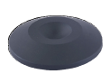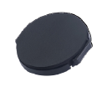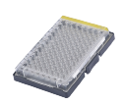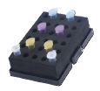
8S-1 8S-2 8S-3 8S-4
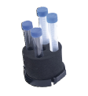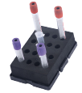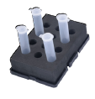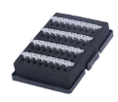
8S-5 8S-6 8S-7 8S-8

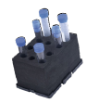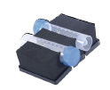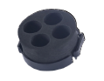
8S-9 8S-10 8S-11

- Packing List
Name | Qty
Host | 1 piece
Power Cord | 1 piece
Standard（8S-1、8S-2、8S-3、8S-4、8S-5、8S-6） | 1 Set
Manual | 1 piece

