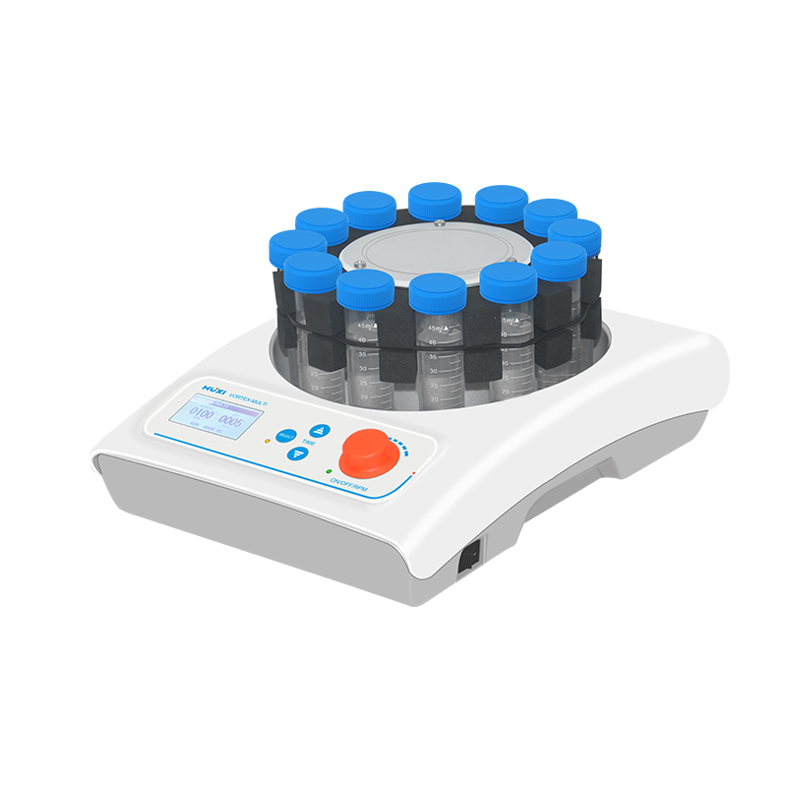

Vortex-MULTI Multi point Vortex Mixer

Application：
●The Vortex-MULTI multi-point vortex mixer is a mixer that can be adapted to up to 110 stations of test tubes,with amplitude up to 3mm and maximum speed up to 2000rpm. It is beautifully shaped, compact and easy to operate,meeting the experimental requirements of simultaneous operation of multiple samples, and is widely used in different fields such as biopharmaceuticals, chemical chemistry and food hygiene.
Main Features：
● DC brushless motor is maintenance-free and can run for a long time;
● With timing operation function, 2 operation modes of continuous operation and timing operation;
● Maximum load capacity up to 2kg.
● LCD display of speed, maximum speed up to 2000rpm;
● Can mix several samples of 0.2~100ml at the same time.

Techncial Parameters：
Model | Vortex-MULTI
Voltage(V) | 100~240
Frequency(HZ) | 50~60
Amplitude（mm） | 3
Motor drive | DC brushless motor
Operation mode | shaking
Working mode | Continuous/Timer
Speed range(rpm) | 200~2000
Speed display | LCD
Timer function | yes
Timer range | 0~9999min
Whole machine power(w) | 75
Standard adapter volume | 12*50ml adapter
Optional adapter volume | 8*100ml Adapter/26*10~15ml Adapter/36*5ml Adapter/54*1.5~2ml Adapter/72*0.5ml Adapter/110*0.2ml Adapter
Max load(kg) | ≤2
Allowable ambient temperature(℃) | 5~40
Allowable ambient humidity(%) | 80
Instrument Size(mm) | 380*260*165
Packing Dimension(mm) | 475*355*310

