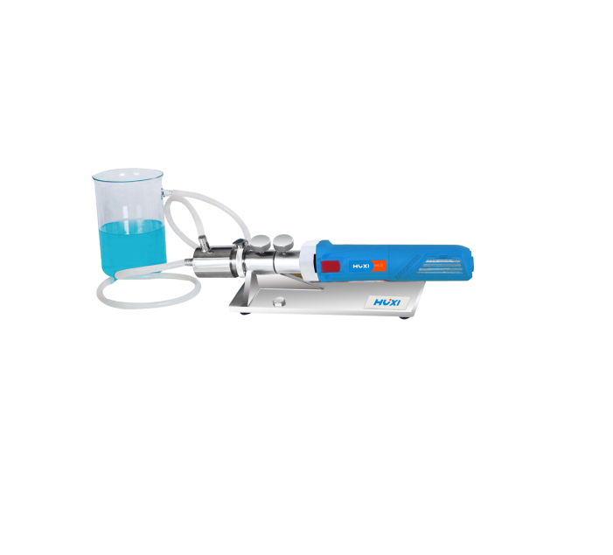

HZR-25 Inline homogenizer

Application：
● HZR-25 Inline emulsifier has high emulsification and mixing efficiency, light weight, modular structure of the whole machine, easy to operate, and can run for a long time. Can make the material 100% through the shear cavity, efficient homogeneity, no dispersion dead angle and other characteristics. Easily meet the simulation of Inline working conditions in the laboratory for circulation or Inline continuous processing. Applicable process: Laboratory Inline processing, can cycle the material, complete Inline dispersion, emulsification, homogenization and mixing.

Main Features：
●A variety of working heads of different specifications to meet the processing capacity of 0.0002~10L;
● 0~999min timing range, the instrument stops automatically after the operation is over;
● High speed motor with brushless motor and long life design for continuous and long time stable operation;
● The highest speed can reach 30,000rpm, providing you with a maximum shear line speed of 27m/s;
● The working head and machine base are made of stainless steel, corrosion resistant;
● Better sealing effect, unique stator-rotor structure, generating super strong shearing force, rapidly reducing the particle size, handling materials more finely and dispersing more uniformly.

Techncial Parameters：
Model | HZR-25
Item No | 1004027001
Motor power | 1250W
Motor type | DC brushless motor
Speed range | 7500~30000rpm
Speed control mode | Gear adjustment
Speed display | Scale display
Capacity（H20） | 1-30L/min
Max viscosity | 10000CP
Standard working head | 25DG
Standard working chamber | Stainless steel non-jacketed working chamber
Contact material | SUS316L
Mechanical seal material | SiC
Inlet and outlet outer diameter | 14 (hose interface)
Overall dimension | 460×120×120mm
Working bracket, base, disassembler | Stainless steel standard
Power supply | 220V/50Hz
Allowable ambient temperature | 5-40℃
Allowable ambient humidity | 80%

